akaBot Center API Guide
TABLE OF CONTENTS
1 Introduction 4
1.1 Overview 4
1.2 Authentication 4
2 Enumerated Types 5
2.1 RobotType 5
2.2 RobotState 6
2.3 JobState 6
2.4 JobCommand 6
2.5 JobSource 6
2.6 EnvironmentType 7
2.7 AssetType 7
2.8 ArgumentType 7
3 ENTITIES 8
3.1 User 8
3.2 Robot 8
3.3 OrganizationUnit 9
3.4 Environment 9
3.5 Packages 9
3.6 WorkFlowParameter 9
3.7 WorkFlow 10
3.8 Job 10
3.9 RobotMappingVM 11
3.10 HeartbeatDTO 11
3.11 Command 11
3.12 HeartbeatData 12
3.13 AssetVM 12
4 API Resources 13
4.1 Users 13
4.2 GetAssociatedProcesses 14
4.3 WorkFlows 15
4.4 WorkFlowVersion 17
4.5 Environments 18
4.6 StartJob 19
4.7 StopJob 20
4.8 GetJob 21
4.9 GetJobs 22
4.10 GetRobotMapping 24
4.11 GetRobots 25
4.12 SubmitHeartbeat 27
4.13 SubmitJobState 28
4.14 PushLogs 29
4.15 GetLogs 30
4.16 GetAsset 32
4.17 SetAsset 33

Introduction

Overview
This is an REST API that exposes entities and their relationships using well defined access, navigation and modification rules. The akaBot Center API Guide is meant to help you easily access and manage all resources available in the Center web interface.
Node: All examples have been built using the http://botcenter.akabot.io Center address. Please use your own Center address when building requests.

Authentication
- Robot
The authentication system for the akaBot Center API uses a bearer token. It requires you to use the robotKey and machineName.
To authenticate to the akaBot Center API do the following:
- Make a POST request to the http://botcenter.akabot.io/api/Account URL
Request
Response
- Copy to the Clipboard the token from the HTTP response, from the "id_token"
- The token must be used in all future requests, in the following format:
- Acount
The authentication system for the akaBot Center API uses a bearer token. It requires you to use the username and password.
To authenticate to the akaBot Center API do the following:
- Make a POST request to the http://botcenter.akabot.io/api/authenticate URL
Request
Response
- Copy to the Clipboard the token from the HTTP response, from the "id_token"
- The token must be used in all future requests, in the following format:

Enumerated Types

RobotType
Name | Value
DEVELOPMENT | 0
ASSITANT | 1
STAGING | 2
PRODUCTION | 3

RobotState
Name | Value
AVAILABLE | 0
BUSY | 1
DISCONNECTED | 2
UNRESPONSIVE | 3

JobState
Name | Value
PENDING | 0
RUNNING | 1
STOPPING | 2
TERMINATING | 3
FAULTED | 4
SUCCESSFUL | 5
STOPPED | 6

JobCommand
Name | Value
START | 0
KILL | 1
STOP | 2
NONE | 3

JobSource
Name | Value
MANUAL | 0
SCHEDULE | 1
AGENT | 2

EnvironmentType
Name | Value
DEV | 0
TEST | 1
PROD | 2

AssetType
Name | Value
STRING | 0
BOOL | 1
INTEGER | 2
CREDENTIAL | 3

ArgumentType
Name | Value
STRING | 0
BOOL | 1
INTEGER | 2

ENTITIES

User
Name | Type | Description
id | Integer
login | String | Username
firstName | String
lastName | String
email | String
imageUrl | String
activated | Boolean
langKey | String
password | String
authorities | Array[String] | List roles

Robot
Name | Type | Description
id | Integer
key | String
name | String
description | String
machineName | String
userName | String
password | String
type | RobotType

OrganizationUnit
Name | Type | Description
id | Integer
name | String
description | String

Environment
Name | Type | Description
id | Integer
name | String
description | String
origanizationUnit | OrganizationUnit
robots | Array[Robot]
type | EnvironmentType

Packages
Name | Type | Description
id | Integer
name | String
description | String
version | String
fileName | String
status | Bool

WorkFlowParameter
Name | Type | Description
id | Integer
name | String
value | String
type | ArgumentType

WorkFlow
Name | Type | Description
id | Integer
name | String
processKey | String
description | String
title | String
version | String
environment | Environment
packages | Packages
parameters | Array[WorkFlowParameter]

Job
Name | Type | Description
id | Integer
jobKey | String
state | JobState
startTime | DateTime
endTime | DateTime
source | JobSource
command | JobCommand
robotId | Integer
workFlowId | Integer
processSchedulesId | Integer
info | String

RobotMappingVM
Name | Type | Description
id | Integer
robotName | String
robotKey | String
machineName | String
user | String
robotType | RobotType

HeartbeatDTO
Name | Type | Description
robotKey | String
robotState | RobotState
info | String
jobKey | String
jobState | JobState
processKey | String

Command
Name | Type | Description
robotKey | String
type | JobCommand
source | JobSource
id | Integer
packageId | String
packageVersion | String
packagePath | String
userName | String
password | String
processKey | String
processName | String
parameters | Collection(WorkFlowParameter)

HeartbeatData
Name | Type | Description
robotKey | String
userName | String
robotName | String
data | Command

AssetVM
Name | Type | Description
name | String
type | AssetType
robotKey | String
userName | String
password | String
value | String

API Resources
Following API endpoint and resources are exposed to be accessible with appropriate authorization.

Users
Get User collections. Supported methods: Get
Parameters
Name | Type | Required | Description
organizationUnitId | Integer | False
searchuser | String | False | Login(username)
page | Integer | False | Page number of the requested page
size | Integer | False | Size of a page(top)
sort | String | False | Sorting criteria in the format: property(,asc|desc)  Ex: login,asc
Response
ReturnType: Collection(User)
Example:
Make a GET request to the http://botcenter.akabot.io/api/users URL
Params:
Headers:
Response:
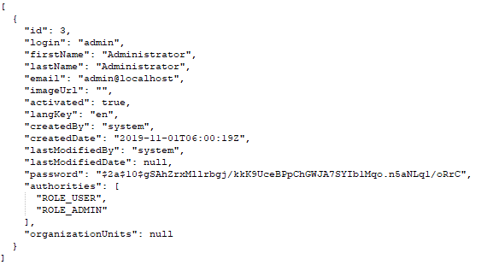

GetAssociatedProcesses
Returns a collection of all available associated process of a Agent. Supported methods: Get
Parameters
Name | Type | Description
robotKey | String
Response
ReturnType: Collection(WorkFlow)
Example:
Make a GET request to the http://botcenter.akabot.io/api/robotsservice/GetAssociatedProcesses URL
Params:
Headers:
Response:
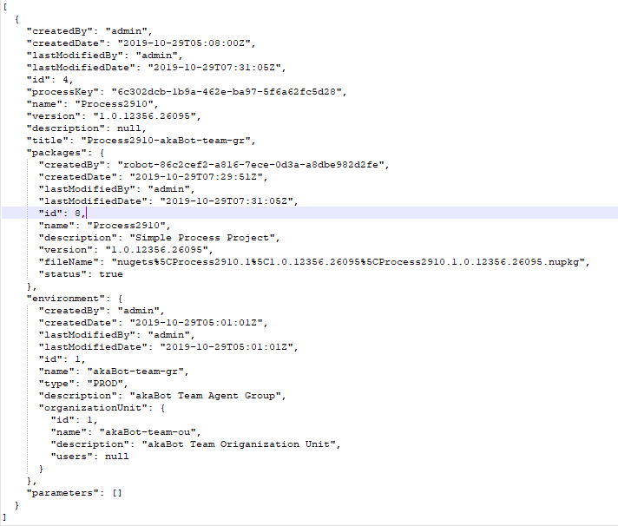

WorkFlows
Get WorkFlow collections. Supported methods: Get
Parameters
Name | Type | Required | Description
organizationUnitId | Integer | False
environmentId | Integer | False | Agent Group ID
environmentName | String | False | Agent Group Name
workflowId | Integer | False
workflowName | String | False
page | Integer | False | Page number of the requested page
size | Integer | False | Size of a page(top)
sort | String | False | Sorting criteria in the format: property(,asc|desc)  Ex: name,asc
Response
ReturnType: Collection(WorkFlow)
Example:
Make a GET request to the http://botcenter.akabot.io/api/work-flows URL
Params:
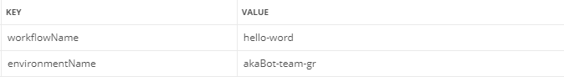
Headers:
Response:
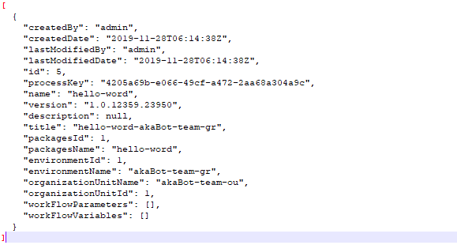

WorkFlowVersion
Get WorkFlow version. Supported methods: Get
Parameters
Name | Type | Required | Description
workflowId | Long | True
Response
ReturnType: String
Example:
Make a GET request to the http://botcenter.akabot.io/api/workflowversion URL
Params:
Headers:
Response:
1.0.12380.19828

Environments
Get Agent Group. Supported methods: Get
Parameters
Name | Type | Required | Description
organizationUnitId | Integer | False
environmentname | String | False | Agent Group Name
page | Integer | False | Page number of the requested page
size | Integer | False | Size of a page(top)
sort | String | False | Sorting criteria in the format: property(,asc|desc)  Ex: name,asc
Response
ReturnType: Collection(Environment)
Example:
Make a GET request to the http://botcenter.akabot.io/api/environments URL
Params:
Headers:
Response:
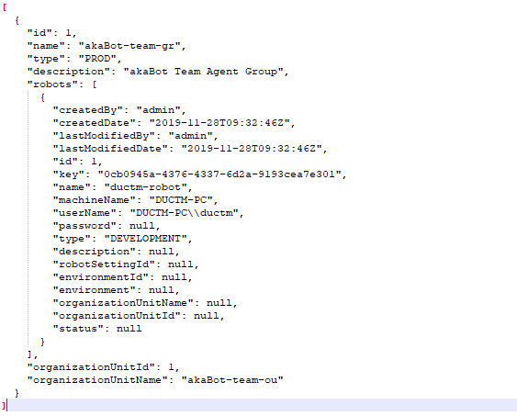

StartJob
Adds a new job and sets it in Pending state for each Agent based on the input parameters and notifies the respective Agents about the pending job. HTTP method: Post
Parameters
Name | Type | Description
jobDTO | Job
Response
ReturnType: Job
Example:
Make a POST request to the http://botcenter.akabot.io/api/jobs URL
Headers:
Request:

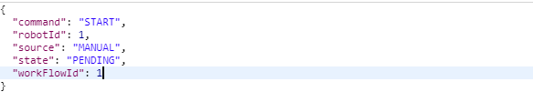
Response:
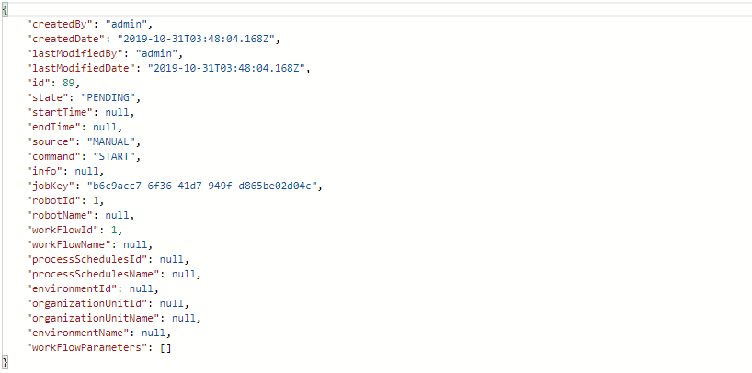

StopJob
Cancels or terminates the specified job. Supported methods: Put
Parameters
Name | Type | Description
id | Integer | jobId
value | String(STOP, KILL)
Response
ReturnType: Job
Example:
Make a PUT request to the http://botcenter.akabot.io/api/jobs/{id}/{value} URL
Headers:
Response
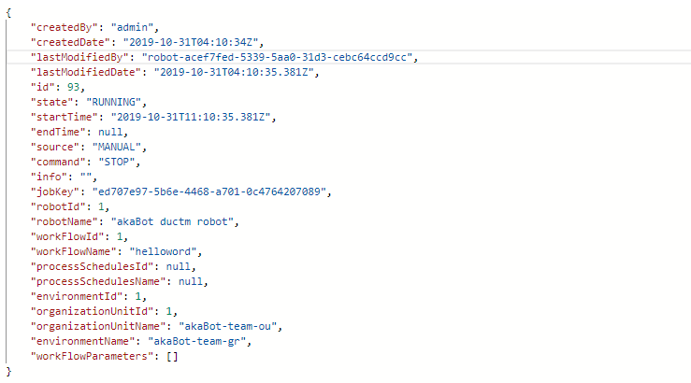

GetJob
Get job information. Supported methods: Get
Parameters
Name | Type | Description
id | Integer | jobId
Response
ReturnType: Job
Example:
Make a GET request to the http://botcenter.akabot.io/api/jobs/{id} URL
Headers:
Response
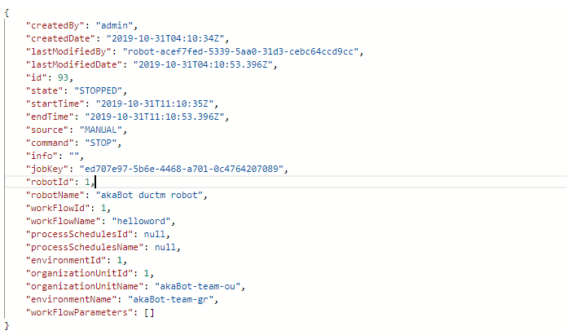

GetJobs
Get Job collections. Supported methods: Get
Parameters
Name | Type | Required | Description
organizationUnitId | Integer | False
environmentId | Integer | False | Agent Group ID
robotId | Integer | False
scheduleId | Integer | False
state | String | False | (PENDING, RUNNING, STOPPED, FAULTED, SUCCESSFUL).  Supported multiple states, separated by commas
page | Integer | False | Page number of the requested page
size | Integer | False | Size of a page(top)
sort | String | False | Sorting criteria in the format: property(,asc|desc)  Ex: startTime,desc
Response
ReturnType: Collection(Job)
Example:
Make a GET request to the http://botcenter.akabot.io/api/jobs URL
Params:
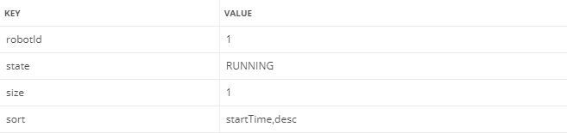
Headers:
Response:
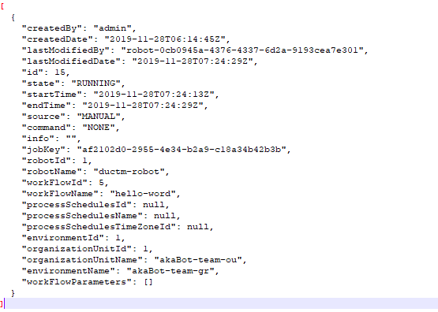

GetRobotMapping
Get robot mapping information. Supported methods: Get
Parameters
Name | Type | Description
licenseKey | String | Agent key
machineName | String
Response
ReturnType: RobotMappingVM
Example:
Make a GET request to the http://botcenter.akabot.io/api/robotsservice/GetRobotMappings URL
Params:
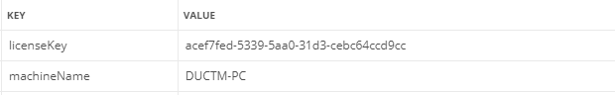
Headers:
Response:
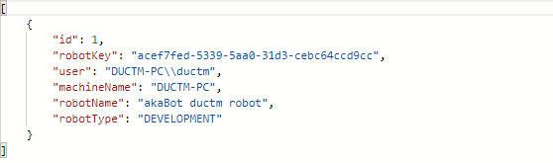

GetRobots
Get Robot collections. Supported methods: Get
Parameters
Name | Type | Required | Description
organizationUnitId | Integer | False
environmentId | Integer | False | Agent Group ID
robotId | Integer | False
robot_type | Integer | False | DEVELOPMENT(0), ASSITANT(1), STAGING(2), PRODUCTION(3)
robot_status | Integer | False | AVAILABLE(0), BUSY(1), DISCONNECTED(2), UNRESPONSIVE(3)
search | String | False | Agent name(robot name)
page | Integer | False | Page number of the requested page
size | Integer | False | Size of a page(top)
sort | String | False | Sorting criteria in the format: property(,asc|desc)  Ex: name,asc
Response
ReturnType: Collection(Robot)
Example:
Make a GET request to the http://botcenter.akabot.io/api/robots URL
Params:
Headers:
Response:
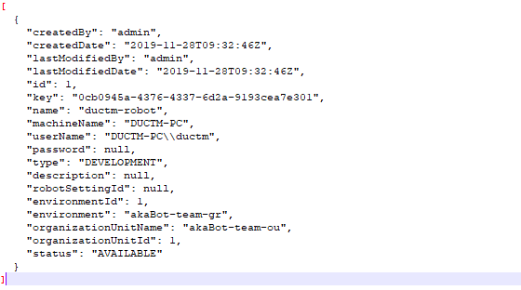

SubmitHeartbeat
Submit status of agent and get list tasks command. Supported methods: Post
Parameters
Name | Type | Description
heartbeatDTO | HeartbeatDTO
Response
ReturnType: HeartbeatData
Example:
Make a POST request to the http://botcenter.akabot.io/api/robotsservice/SubmitHeartbeat URL
Request:
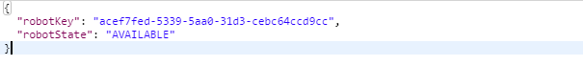
Headers:
Response:
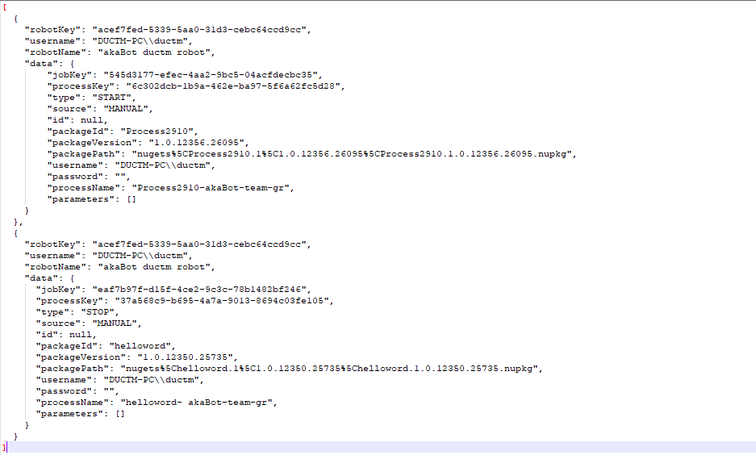

SubmitJobState
Submit status of task from agent. Supported methods: Post
Parameters
Name | Type | Description
heartbeatDTO | HeartbeatDTO
Response

Example:
Make a POST request to the http://botcenter.akabot.io/api/robotsservice/SubmitJobState URL
Request:
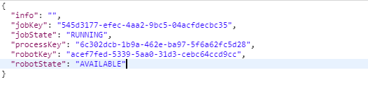
Headers:
Response:
1

PushLogs
Push log to center. Supported methods: Post
Parameters
Name | Type | Description
robotName | String
messages | Array(String)
Response
ReturnType: Bool
Example:
Make a POST request to the http://botcenter.akabot.io/api/logs/v1 URL
Request:
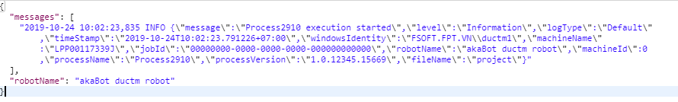
Headers:
Response:
True

GetLogs
Get Log collections. Supported methods: Get
Parameters
Name | Type | Required | Description
robotName | String | False
workflowId | Integer | False
level | Integer | False | OFF(0), FATAL(1), ERROR(2), WARNING(3), INFORMATION(4), DEBUG(5), VERBOSE(6)
jobId | String | False
queryString | String | False | Keyword to query from log message
page | Integer | False | Page number of the requested page
size | Integer | False | Size of a page(top)
sort | String | False | Sorting criteria in the format: property(,asc|desc)  Ex: timeStamp,desc
Response
ReturnType: Collection(Job)
Example:
Make a GET request to the http://botcenter.akabot.io/api/logs URL
Params:
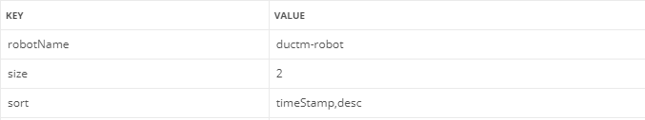
Headers:
Response:
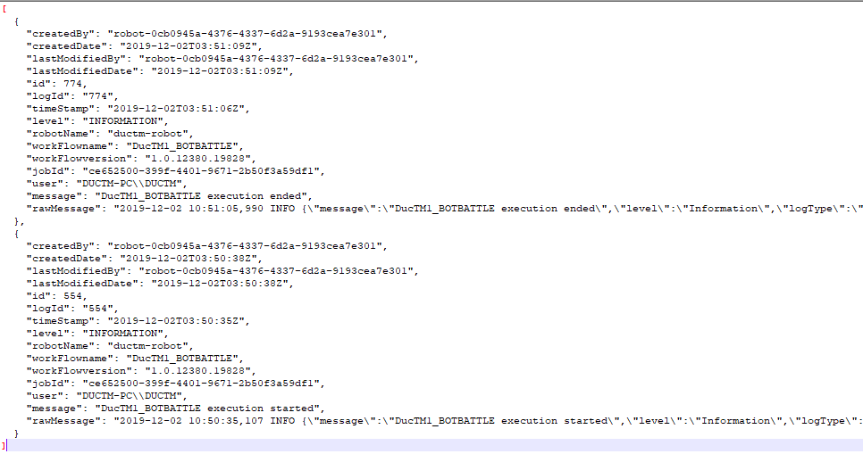

GetAsset
Get asset information. Supported methods: Get
Parameters
Name | Type | Description
assetName | String
robotKey | String
Response
ReturnType: AssetVM
Example:
Make a GET request to the http://botcenter.akabot.io/api/studioservice/GetAsset URL
Params:
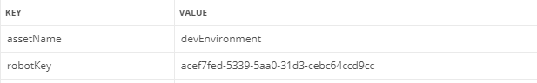
Headers:
Response:

SetAsset
Update value of asset. Supported methods: Post
Parameters
Name | Type | Description
assetVM | AssetVM
Response
ReturnType: Bool
Example:
Make a POST request to the http://botcenter.akabot.io/api/studioservice/SetAsset URL
Request:
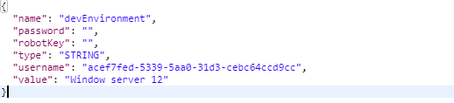
Headers:
Response:
True

